Guilas JovenCarl C. 6BlockTech
NW-301 02/12/2025

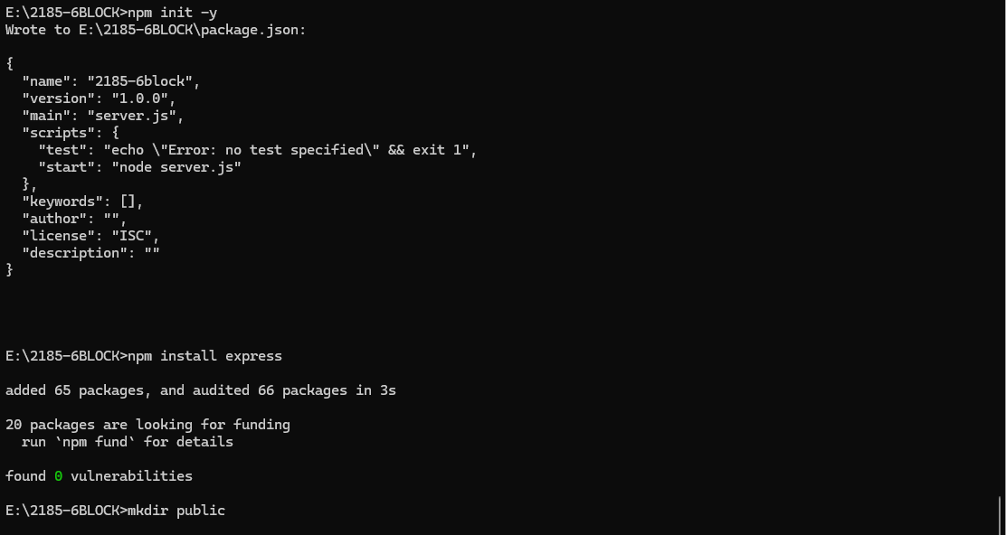
Reflection:
Even though clicking Connect Wallet seems simple, I learned that a lot is happening in the background MetaMask is checking the network, managing permissions, and preparing to sign transactions. This made me appreciate how much responsibility is placed on the user, especially since one wrong approval could lead to mistakes or risks.
